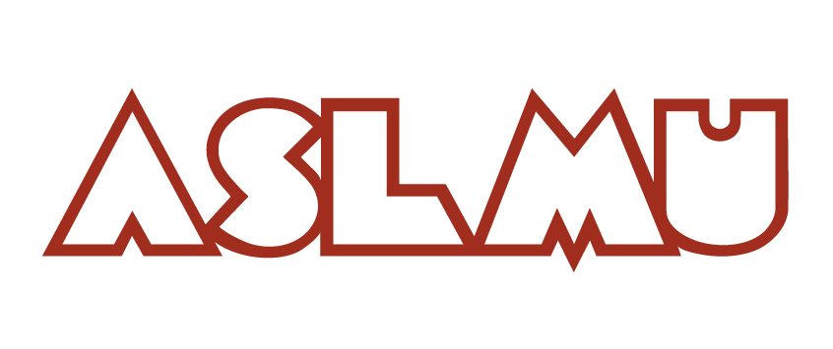
Associated Students of Loyola Marymount University
Senate Meeting Agenda
Wednesday, October 9th, 2019 | 12:40 PM | Malone 112

- Preliminaries
- Call to Order
- Quorum Check
- Agenda Changes
- Hearing of the Public

- Discussion Items
  - Budget Update (Ariana)
  - Budget Proposal (Ariana)
  - Indigenous Recognition Resolution (Kilan and Kaylene)
  - SAFAB Update (Taylor C.)
  - Divestment Discussion (Eco Students)
  - Kudos/ Shout Outs (Alex)
  - Triweekly Feedback (Alex)
- Action Items
- Open Forum and Announcements
A. Fill out Survey
- Adjournment

